|  |
| --- |
| Date/Location |
| 03/30/2022 @Zoom, 5:00 – 6:00 PM |

|  |  |  |  |
| --- | --- | --- | --- |
| Attendees | |  | |
| Client | MAVDEV | UT Professor |
| Joe Saceric | Ammar Lokhandwala | Clint Tuttle |
| Umera Khan | Maria Frausto |  |
|  | Michael Gurch |  |
|  | Victoria Sheraden |  |
|  | Vivian Bui |  |

|  |
| --- |
| Meeting Agenda |

1. **Current Trello Board**

For Meetings:



For Development:

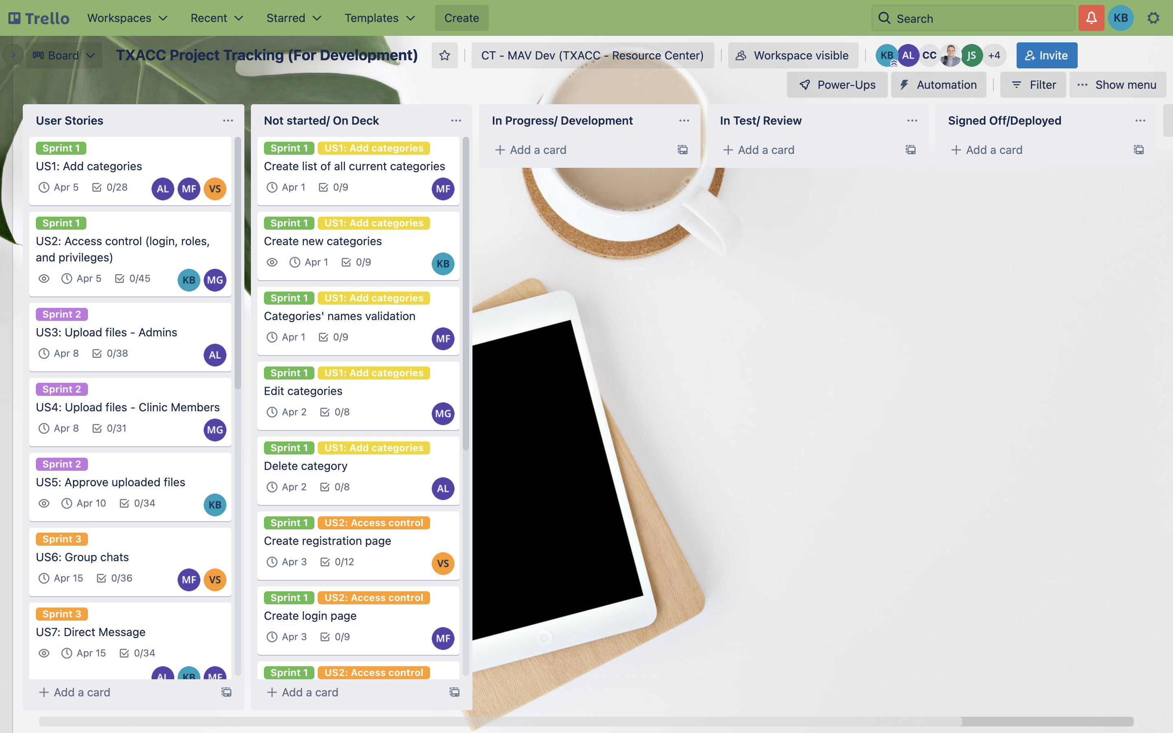

1. **Discussion Agenda**
2. Overview of Inception Analysis
3. Evaluation Table Review
4. Sprint Management
5. Q&A